PHASE 5
Project Development
Actual Source Code
Key implementation snippets from the BlogNest (ContentGen) backend are shown below.
Post Schema
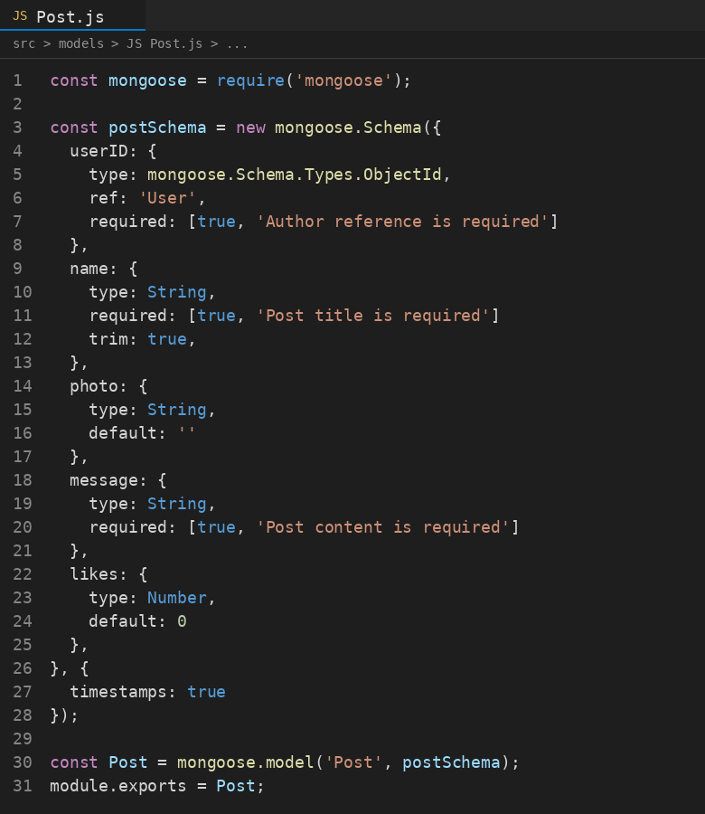
Fig 5.1 – Mongoose Post schema definition
User Schema

Fig 5.2 – Mongoose User schema definition
Database Connection

Fig 5.3 – MongoDB connection module using Mongoose
Application Entry Point (server.js)

Fig 5.4 – server.js – Express server initialization and database bootstrap
Database Implementation
MongoDB was used as the NoSQL document database, with Mongoose ODM enforcing schema validation. Three primary collections were implemented:
- Users collection – stores name, email (unique), hashed password, and role (Admin, Editor, Author, Reader), used for authentication and role-based authorization.
- Posts collection – stores title, photo path, message content, like count, and a foreign-key reference to the authoring user, supporting the One-to-Many relationship between users and their blog posts.
- Comments collection – stores comment content, moderation status (approved, pending, spam), and references to both the parent post and the commenting user, supporting the One-to-Many relationships between posts/users and comments.
Modules Developed
- Authentication Module – registration, login, JWT issuance, bcrypt password hashing.
- Blog/Post Module – full CRUD for blog posts, including drafts, scheduling, and status transitions (Draft, Pending Approval, Scheduled, Published).
- Category & Tag Module – manages taxonomy for organizing and filtering posts.
- Comment Module – comment creation and moderation queue (approve, flag as pending, mark as spam).
- AI Content Module – integrates Google Gemini AI to auto-generate blog drafts (/api/ai/generate-blog) and summarize long-form content (/api/ai/summarize).
- Admin Module – user account management, role assignment, and API/service health monitoring.
- Middleware – authentication guard, role-based access control, request sanitization, centralized error handling.
Important Implementation Details
- Passwords are never stored in plain text – bcrypt.js hashes them before persistence.
- JWT tokens are issued on login and validated on every protected route via middleware.
- Role-based access control restricts administrative and editorial actions to the Admin, Editor, and Author tiers, while Readers retain read/comment access only.
- Centralized error-handling middleware returns consistent JSON error responses across the API.
- Request sanitization prevents XSS and NoSQL injection through parameter cleansing on all incoming payloads.

